Tutorial for SurfaceIntersection Function

**Overview**

Function calculates intersection of any two triangulated surfaces using triangle/triangle intersection algorithm proposed by Tomas Möller (1997) and implemented as highly vectorized MATLAB code. The algorithm was expanded to include calculation of the intersection surface, in addition to boolean matrix cataloging which triangle from one surface intersects with which triangle in the other surface. Function can be used for contour line calculations and can handle surfaces residing on the same plane.

**Examples**

**By Jarek Tuszynski (**[**jaroslaw.w.tuszynski@leidos.com**](mailto:jaroslaw.w.tuszynski@leidos.com)**)**

Triangle/triangle intersection using the algorithm proposed by Tomas Möller (1997), implemented as highly vectorized MATLAB code. The algorithm was expanded to include calculation of the intersection surface.

[intMatrix, intSurface] = SurfaceIntersection(surface1, surface2) calculates the intersection of surfaces 1 and 2. Code can either return just the matrix indicating which face of surface1 intersected with face of surface2, which is calculated using Tomas Moller algorithm, or can also return the actual line or surface of intersection. In case when parts of the surface 1 and 2 lay on the same plane the intersection is a 2D area instead of 1D edge. In such a case the intersection area will be triangulated and intSurface.edges will hold the edges of the triangulation surface and intSurface.faces will hold the faces.

**Contents**

* [References](https://ww2.mathworks.cn/matlabcentral/mlc-downloads/downloads/submissions/48613/versions/1/previews/html/SurfaceIntersection_tutorial.html#1)
* [Change History](https://ww2.mathworks.cn/matlabcentral/mlc-downloads/downloads/submissions/48613/versions/1/previews/html/SurfaceIntersection_tutorial.html#2)
* [Licence](https://ww2.mathworks.cn/matlabcentral/mlc-downloads/downloads/submissions/48613/versions/1/previews/html/SurfaceIntersection_tutorial.html#3)
* [Define three surfaces and plot them](https://ww2.mathworks.cn/matlabcentral/mlc-downloads/downloads/submissions/48613/versions/1/previews/html/SurfaceIntersection_tutorial.html#4)
* [Run SurfaceIntersection and plot the results](https://ww2.mathworks.cn/matlabcentral/mlc-downloads/downloads/submissions/48613/versions/1/previews/html/SurfaceIntersection_tutorial.html#5)
* [Test SurfaceIntersection on surfaces laying on the same plane (coplanar)](https://ww2.mathworks.cn/matlabcentral/mlc-downloads/downloads/submissions/48613/versions/1/previews/html/SurfaceIntersection_tutorial.html#6)
* [Test SurfaceIntersection on surfaces laying on the same plane (coplanar)](https://ww2.mathworks.cn/matlabcentral/mlc-downloads/downloads/submissions/48613/versions/1/previews/html/SurfaceIntersection_tutorial.html#7)
* [Compare runs with and without intersection calculation: test #1](https://ww2.mathworks.cn/matlabcentral/mlc-downloads/downloads/submissions/48613/versions/1/previews/html/SurfaceIntersection_tutorial.html#8)
* [Compare runs with and without intersection calculation: test #2](https://ww2.mathworks.cn/matlabcentral/mlc-downloads/downloads/submissions/48613/versions/1/previews/html/SurfaceIntersection_tutorial.html#9)
* [Draw contour lines of a sphere](https://ww2.mathworks.cn/matlabcentral/mlc-downloads/downloads/submissions/48613/versions/1/previews/html/SurfaceIntersection_tutorial.html#10)
* [Draw contour lines of a cone or conics](https://ww2.mathworks.cn/matlabcentral/mlc-downloads/downloads/submissions/48613/versions/1/previews/html/SurfaceIntersection_tutorial.html#11)

**References**

Based on Triangle/triangle intersection test routine by Tomas Möller, 1997. See article "A Fast Triangle-Triangle Intersection Test", Journal of Graphics Tools, 2(2), 1997 <http://web.stanford.edu/class/cs277/resources/papers/Moller1997b.pdf><http://fileadmin.cs.lth.se/cs/Personal/Tomas_Akenine-Moller/code/opttritri.txt>

**Change History**

* 2014-11-17 - original version

**Licence**

The package is distributed under BSD Licence

format compact; % viewing preference

clear variables;

type('license.txt')

Copyright (c) 2014, Jaroslaw Tuszynski

All rights reserved.

Redistribution and use in source and binary forms, with or without

modification, are permitted provided that the following conditions are

met:

* Redistributions of source code must retain the above copyright

notice, this list of conditions and the following disclaimer.

* Redistributions in binary form must reproduce the above copyright

notice, this list of conditions and the following disclaimer in

the documentation and/or other materials provided with the distribution

THIS SOFTWARE IS PROVIDED BY THE COPYRIGHT HOLDERS AND CONTRIBUTORS "AS IS"

AND ANY EXPRESS OR IMPLIED WARRANTIES, INCLUDING, BUT NOT LIMITED TO, THE

IMPLIED WARRANTIES OF MERCHANTABILITY AND FITNESS FOR A PARTICULAR PURPOSE

ARE DISCLAIMED. IN NO EVENT SHALL THE COPYRIGHT OWNER OR CONTRIBUTORS BE

LIABLE FOR ANY DIRECT, INDIRECT, INCIDENTAL, SPECIAL, EXEMPLARY, OR

CONSEQUENTIAL DAMAGES (INCLUDING, BUT NOT LIMITED TO, PROCUREMENT OF

SUBSTITUTE GOODS OR SERVICES; LOSS OF USE, DATA, OR PROFITS; OR BUSINESS

INTERRUPTION) HOWEVER CAUSED AND ON ANY THEORY OF LIABILITY, WHETHER IN

CONTRACT, STRICT LIABILITY, OR TORT (INCLUDING NEGLIGENCE OR OTHERWISE)

ARISING IN ANY WAY OUT OF THE USE OF THIS SOFTWARE, EVEN IF ADVISED OF THE

POSSIBILITY OF SUCH DAMAGE.

**Define three surfaces and plot them**

% Create Surface #1

[x,y] = pol2cart((0:2)'*2*pi/3,40);

Surface1.vertices = [0 0 110; x y [0; 0; 0]];

Surface1.faces = [1 2 3; 1 3 4; 1 4 2; 2 3 4];

% Create Surface #2

load tetmesh;

TR = triangulation(tet,X);

[Surface2.faces, Surface2.vertices] = freeBoundary(TR);

% Create Surface #3

Surface3.vertices = [x y [30; 30; 30]; y x [60; 60; 60]];

Surface3.faces = [1:3;4:6];

% Plot them

clf; hold on

S=Surface1; trisurf(S.faces, S.vertices(:,1),S.vertices(:,2),S.vertices(:,3),'FaceAlpha', 0.5, 'FaceColor', 'r');

S=Surface2; trisurf(S.faces, S.vertices(:,1),S.vertices(:,2),S.vertices(:,3),'FaceAlpha', 0.5, 'FaceColor', 'g');

S=Surface3; trisurf(S.faces, S.vertices(:,1),S.vertices(:,2),S.vertices(:,3),'FaceAlpha', 0.5, 'FaceColor', 'b');

view([3 1 1])

axis equal

title ('Three test surfaces')

legend({'#1', '#2', '#3'});

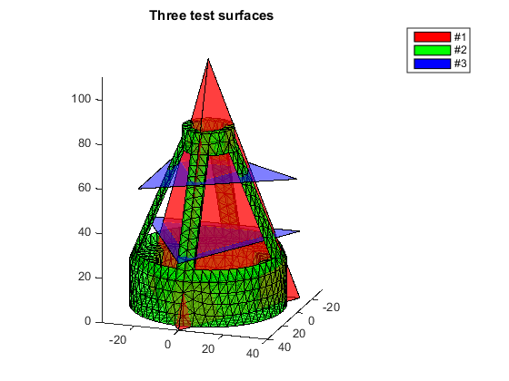

**Run SurfaceIntersection and plot the results**

Parts of Surface #1 and #2 are on the same plane and the intersection is a 2D area instead of collection of 1D edges

[intersect12, Surf12] = SurfaceIntersection(Surface1, Surface2);

[intersect13, Surf13] = SurfaceIntersection(Surface1, Surface3);

[intersect23, Surf23] = SurfaceIntersection(Surface3, Surface2);

clf; hold on

S=Surf12; trisurf(S.faces, S.vertices(:,1),S.vertices(:,2),S.vertices(:,3),'EdgeColor', 'r', 'FaceColor', 'r');

S=Surf13; trisurf(S.faces, S.vertices(:,1),S.vertices(:,2),S.vertices(:,3),'EdgeColor', 'g', 'FaceColor', 'g');

S=Surf23; trisurf(S.faces, S.vertices(:,1),S.vertices(:,2),S.vertices(:,3),'EdgeColor', 'b', 'FaceColor', 'b');

title ('Surface/Surface intersections')

legend({'#1/#2', '#1/#3', '#2/#3'});

view([3 1 1])

axis equal

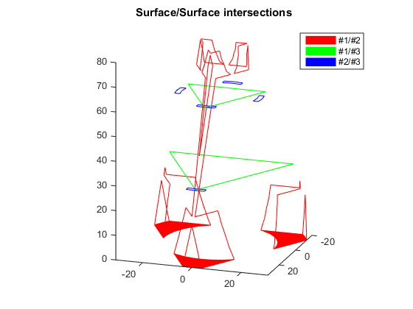

**Test SurfaceIntersection on surfaces laying on the same plane (coplanar)**

clf; hold on

% Define surface #1

SurfaceA.vertices = rand([10,2]);

Sa = delaunayTriangulation(SurfaceA.vertices);

SurfaceA.faces = Sa.ConnectivityList;

SurfaceA.vertices(:,3)=0;

% Define surface #2

SurfaceB.vertices = rand([10,2]);

Sb = delaunayTriangulation(SurfaceB.vertices);

SurfaceB.faces = Sb.ConnectivityList;

SurfaceB.vertices(:,3)=0;

% Calculate intersection

[~, SurfAB] = SurfaceIntersection(SurfaceA, SurfaceB);

% Plot all

S=SurfaceA; trisurf(S.faces, S.vertices(:,1),S.vertices(:,2),S.vertices(:,3),'EdgeColor', 'k', 'FaceAlpha', 0.5, 'FaceColor', 'r');

S=SurfaceB; trisurf(S.faces, S.vertices(:,1),S.vertices(:,2),S.vertices(:,3),'EdgeColor', 'k', 'FaceAlpha', 0.5, 'FaceColor', 'b');

S=SurfAB; trisurf(S.faces, S.vertices(:,1),S.vertices(:,2),S.vertices(:,3),'EdgeColor', 'k', 'FaceAlpha', 0.5, 'FaceColor', 'm');

legend({'Surface #1', 'Surface #2', 'Intersection'});

axis equal

title('Coplanar surfaces with 10 points each')

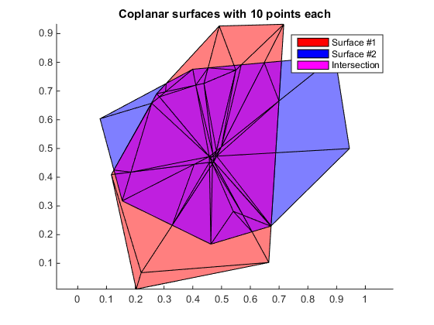

**Test SurfaceIntersection on surfaces laying on the same plane (coplanar)**

clf; hold on

% Define surface #1

SurfaceA.vertices = rand([100,2]);

Sa = delaunayTriangulation(SurfaceA.vertices);

SurfaceA.faces = Sa.ConnectivityList;

SurfaceA.vertices(:,3)=0;

% Define surface #2

SurfaceB.vertices = rand([100,2]);

Sb = delaunayTriangulation(SurfaceB.vertices);

SurfaceB.faces = Sb.ConnectivityList;

SurfaceB.vertices(:,3)=0;

% Calculate intersection

[~, SurfAB] = SurfaceIntersection(SurfaceA, SurfaceB);

% Plot all

S=SurfaceA; trisurf(S.faces, S.vertices(:,1),S.vertices(:,2),S.vertices(:,3),'EdgeColor', 'k', 'FaceAlpha', 0.5, 'FaceColor', 'r');

S=SurfaceB; trisurf(S.faces, S.vertices(:,1),S.vertices(:,2),S.vertices(:,3),'EdgeColor', 'k', 'FaceAlpha', 0.5, 'FaceColor', 'b');

S=SurfAB; trisurf(S.faces, S.vertices(:,1),S.vertices(:,2),S.vertices(:,3),'EdgeColor', 'k', 'FaceAlpha', 0.5, 'FaceColor', 'm');

legend({'Surface #1', 'Surface #2', 'Intersection'});

axis equal

title('Coplanar surfaces with 100 points each')

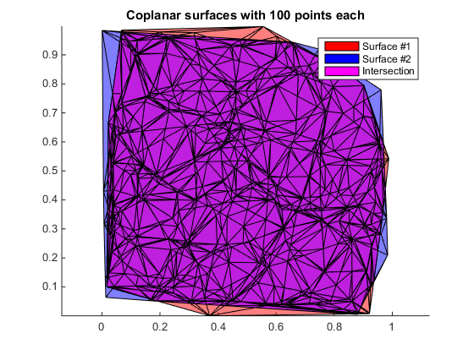

**Compare runs with and without intersection calculation: test #1**

% Define two surfaces

Surface1 = surf2patch(membrane(1,30),'triangles');

Surface2 = surf2patch(membrane(3,30),'triangles');

% add a bit of perturbation to x and y coordinates of surface 2

Surface2.vertices(:,1:2) = Surface2.vertices(:,1:2) + 1E-3*randn(size(Surface2.vertices(:,1:2)));

fprintf('25%% coplanar faces.\n# faces in surface 1 = %i; # faces in surface 2 = %i\n', ...

size(Surface1.faces,1), size(Surface2.faces,1));

% Plot two surfaces

clf; hold on

subplot(2,1,1)

patch(Surface1, 'FaceColor', 'b','EdgeColor', 'none', 'FaceAlpha', 0.8);

patch(Surface2, 'FaceColor', 'r','EdgeColor', 'none', 'FaceAlpha', 0.8);

title('Two surfaces')

view(-195, 44)

% Run and time the intersection function

tic; [intersect_a] = SurfaceIntersection(Surface1, Surface2);

fprintf('Run time without intersection calculation is %f\n', toc)

tic; [intersect_b, Surf12] = SurfaceIntersection(Surface1, Surface2);

fprintf('Run time with intersection calculation is %f\n', toc)

% Plot the results

subplot(2,1,2)

S=Surf12; trisurf(S.faces, S.vertices(:,1),S.vertices(:,2),S.vertices(:,3), 'FaceColor', 'g');

view(-195, 44)

title('Surface intersection')

fprintf('Number of face pairs is %i and number of intersections is %i\n', ...

size(Surface1.faces,1)*size(Surface2.faces,1), nnz(intersect_a));

fprintf('Number of differences: %i\n', nnz(intersect_a~=intersect_b));

25% coplanar faces.

# faces in surface 1 = 7200; # faces in surface 2 = 7200

Run time without intersection calculation is 12.934015

Run time with intersection calculation is 19.862958

Number of face pairs is 51840000 and number of intersections is 11023

Number of differences: 0

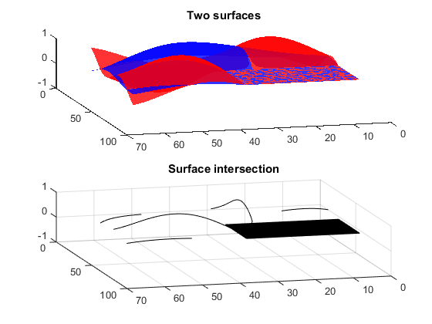

**Compare runs with and without intersection calculation: test #2**

% Define two surfaces

Surface1 = surf2patch(membrane(1,30),'triangles');

Surface2 = surf2patch(membrane(3,30),'triangles');

% add a bit of perturbation to the coordinates of surface 2

Surface2.vertices = Surface2.vertices + 1E-3*randn(size(Surface2.vertices));

fprintf('No coplanar faces.\n# faces in surface 1 = %i; # faces in surface 2 = %i\n', ...

size(Surface1.faces,1), size(Surface2.faces,1));

% Plot two surfaces

clf; hold on

subplot(2,1,1)

patch(Surface1, 'FaceColor', 'b','EdgeColor', 'none', 'FaceAlpha', 0.8);

patch(Surface2, 'FaceColor', 'r','EdgeColor', 'none', 'FaceAlpha', 0.8);

title('Two surfaces')

view(-195, 44)

% Run and time the intersection function

tic; [intersect_a] = SurfaceIntersection(Surface1, Surface2);

fprintf('Run time without intersection calculation is %f\n', toc)

tic; [intersect_b, Surf12] = SurfaceIntersection(Surface1, Surface2);

fprintf('Run time with intersection calculation is %f\n', toc)

subplot(2,1,2)

S=Surf12; trisurf(S.faces, S.vertices(:,1),S.vertices(:,2),S.vertices(:,3), 'FaceColor', 'g');

% Plot the results

view(-195, 44)

title('Surface intersection')

fprintf('Number of face pairs is %i and number of intersections is %i\n', ...

size(Surface1.faces,1)*size(Surface2.faces,1), nnz(intersect_a));

fprintf('Number of differences: %i\n', nnz(intersect_a~=intersect_b));

No coplanar faces.

# faces in surface 1 = 7200; # faces in surface 2 = 7200

Run time without intersection calculation is 5.702677

Run time with intersection calculation is 6.239134

Number of face pairs is 51840000 and number of intersections is 3405

Number of differences: 0

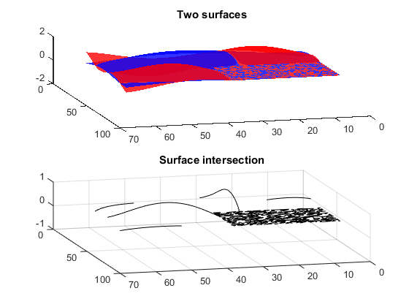

**Draw contour lines of a sphere**

% Create Surface #1: the sphere

[x,y,z] = sphere(50);

DT = delaunayTriangulation(z(:), y(:), x(:));

[Surface1.faces, Surface1.vertices] = freeBoundary(DT);

% Create Surface #2: 11 equally spaced parallel planes

Surface2=[];

for i=0:10

z = -0.95 + i/5;

Surface2.vertices(3*i+(1:3),:) = [2, 0, z; -1, 1.7, z; -1, -1.7, z];

Surface2.faces(i+1,:) = 3*i+(1:3);

end

[~, Surf12] = SurfaceIntersection(Surface1, Surface2);

Surf12.vertices(:,3) = -1.5; % project the contour lines on a single plane

% plot the results

figure(1); clf; hold on

S=Surface1; trisurf(S.faces, S.vertices(:,1),S.vertices(:,2),S.vertices(:,3),'FaceAlpha', 0.5, 'FaceColor', 'r')

S=Surface2; trisurf(S.faces, S.vertices(:,1),S.vertices(:,2),S.vertices(:,3),'FaceAlpha', 0.5, 'FaceColor', 'b')

S=Surf12; line(...

[S.vertices(S.edges(:,1),1), S.vertices(S.edges(:,2),1)]',...

[S.vertices(S.edges(:,1),2), S.vertices(S.edges(:,2),2)]',...

[S.vertices(S.edges(:,1),3), S.vertices(S.edges(:,2),3)]',...

'Color', 'r');

axis equal

view(170, 20)

Warning: Duplicate data points have been detected and removed.

The Triangulation indices are defined with respect to the unique set of points

in delaunayTriangulation property X.

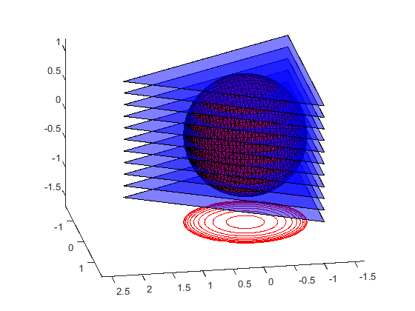

**Draw contour lines of a cone or conics**

% Create Surface #1: the double cone

XYZ=[];

XYZ(1,:)=[0 0 0];

for z = 1:100

n=z+5;

[x,y] = pol2cart((1:n)'*2*pi/n,z);

XYZ = [XYZ; [x y z*x./x]];

end

DT = delaunayTriangulation(XYZ(:,1),XYZ(:,2));

Surface1.faces = [DT.ConnectivityList; DT.ConnectivityList+size(XYZ,1)];

Surface1.vertices = [XYZ(:,3),XYZ(:,2),XYZ(:,1); -XYZ(:,3),XYZ(:,2),XYZ(:,1)]/100;

S=Surface1; trisurf(S.faces, S.vertices(:,1),S.vertices(:,2),S.vertices(:,3),'FaceAlpha', 0.5, 'FaceColor', 'r');

% Create Surface #2: 11 equally spaced parallel planes

Surface2=[];

for i=0:10

z = -0.95 + i/5;

Surface2.vertices(3*i+(1:3),:) = [2, 0, z; -1, 1.7, z; -1, -1.7, z];

Surface2.faces(i+1,:) = 3*i+(1:3);

end

[~, Surf12] = SurfaceIntersection(Surface1, Surface2);

Surf12.vertices(:,3) = -1.5; % project the contour lines on a single plane

% plot the results

figure(1); clf; hold on

S=Surface1; trisurf(S.faces, S.vertices(:,1),S.vertices(:,2),S.vertices(:,3),'FaceAlpha', 0.5, 'FaceColor', 'r')

S=Surface2; trisurf(S.faces, S.vertices(:,1),S.vertices(:,2),S.vertices(:,3),'FaceAlpha', 0.5, 'FaceColor', 'b')

S=Surf12; line(...

[S.vertices(S.edges(:,1),1), S.vertices(S.edges(:,2),1)]',...

[S.vertices(S.edges(:,1),2), S.vertices(S.edges(:,2),2)]',...

[S.vertices(S.edges(:,1),3), S.vertices(S.edges(:,2),3)]',...

'Color', 'r');

axis equal

view(-190, 15)

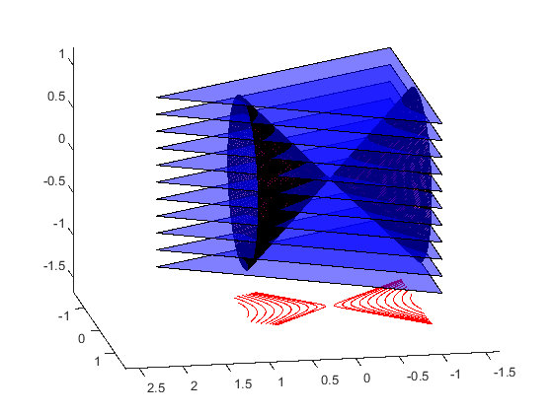

[*Published with MATLAB® R2014b*](http://www.mathworks.com/products/matlab/)